Physics 30 Lesson 30

Light Spectra & Excitation States

So far in our study of the nature of the atom we have learned about the nuclear model of the atom and the quantization of light energy. In this lesson we will learn about **light spectra** and how they led to our current conception of the atom.

# Types of spectra

Light spectra are the patterns produced when light is either **dispersed** through an equilateral glass prism or is **diffracted** apart by a diffraction grating – i.e. light is separated into its colours. There are **three types** of spectra.

## Continuous Spectrum

When a solid or a liquid is made white hot white light is emitted. When the light passes through a prism it is dispersed into its colours. The short wavelengths (violet, blue) are refracted more by the prism than the longer wavelengths (orange, red). The result is a **continuous spectrum** of light from violet to red.



continuous spectrum



white light source

v i b g y o r

Recall from Lesson 28 that a hot solid or liquid acts as a blackbody radiator and that the light emitted is not affected by the type or kind of solid or liquid being heated.

## Emission / Bright-line Spectrum

Gases will also produce light when heated to a high temperature. In 1752 a Scottish physicist name Thomas Melvill observed the spectra produced by a heated gas.

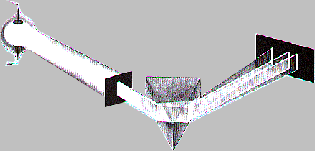

emission spectrum

heated or electrified gas

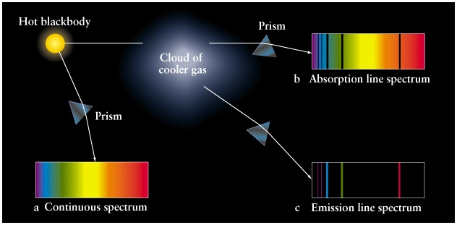

v i b g y o r

Melvill discovered that gases do not produce a continuous spectrum, rather they produce a spectrum that is composed of **bright colored lines against a black background**. We call this type of spectrum a **bright line** or **emission spectrum** (i.e. the gas emits the light). He also noted that the colors and locations of the bright lines were differentwhen different gaseswere used.

By 1823, scientists had found that gases could be induced to glow when excited by electricity. If the gas was sealed inside a tube with an anode and a cathode, it would glow when electricity was passed through it. Modern electric signs, for example, are composed of tubes with neon, argon, and other gases which are exposed to a potential difference. Each gas gives off its own colours of light.

John Herschel, the British Astronomer, suggested that if each gas had a characteristic bright line spectrum then elements might be identified by their spectrum. **Spectral analysis** was the result of this idea. In 1860, Gustav Kirchoff and RobertBunsen discovered two substances with unique emission spectra that did not match any known spectrum at the time. Using this technique they had isolated two new elements: cesiumand rubidium. Many other elements were discovered using this technique.

## Absorption / Dark-line Spectrum

In 1802, British scientistWilliam Wollaston found seven dark lines within the continuous spectrum produced by light from the sun. In 1814, the German physicist Joseph van Fraunhofer was able to detect hundreds of these dark lines formed on the continuous solar spectrum. These lines are now called **Fraunhofer Lines** in his honour.

In 1859, Gustav Kirchoff was able to produce a **dark line** (**absorption**) **spectrum** by passing white light through a glass container holding cold sodium gas and then viewing the emerging light with a prism. The gas in the container absorbed a few discreet wavelengths or colors of light while the majority of the light passed through the gas.

absorption spectrum

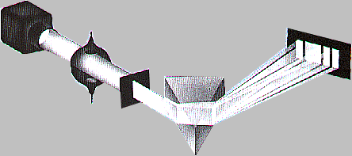

full spectrum white light source

cool gas

v i b g y o r

Analysis of the dark Fraunhofer lines of solar spectra indicated that the lines matched those of many known elements. Thus the atmosphere of the sun contained the same elements as those on Earth. The chemical composition of the outer region of the sun and of distant stars and galaxies has been determined by this process. The result indicates that other things in the universe are made of the same elements and molecules that we find on Earth.

When spectra were recorded and analyzed from galaxies, it was found that their spectra were shifted from their normal position. Some were shifted toward the blue end of the spectrum, while others were shifted toward the red. This shift was interpreted as a Doppler shift which was the result of the relative movement between the Earth and the galaxy – red shift indicated the galaxy was moving away, blue shift indicated movement toward the Earth. There are a few neighbouring galaxies which are slightly blue-shifted, but the vast majority are red shifted. In fact, the more distant the galaxy, the greater its red shift. Thus we live in an expanding universe. When this was discovered, it was not long before the theory of the Big Bang was developed. The universe is expanding as a result of the original explosion between 15 and 18 billion years ago.

Refer to Pearson pages 771 to 773 for a discussion about spectroscopy.

Ask to see the spectra of gases demonstration. In addition, study the spectrum poster on the wall, and I recommend that you go to the following website to look at the absorption spectra of different elements:

<http://jersey.uoregon.edu/elements/Elements.html>

# Comparison of emission and absorption spectra

When Kirchoff compared the emission spectra with the absorption spectra of sodium vapor, he noted that the position of the dark lines in the absorption spectra corresponded exactly with the position of the two bright yellow lines in the emission spectra.

Emission

Absorption

All other elements were quickly checked and an exact match up resulted for all the other known elements. Apparently the light energy **absorbed** by an element from white light matched exactly the light energy **emitted** by the excited element. However, a rather puzzling phenomenon was that there were **always more lines in the emission spectrum than in the absorption spectrum**. Why? We will answer this question below.

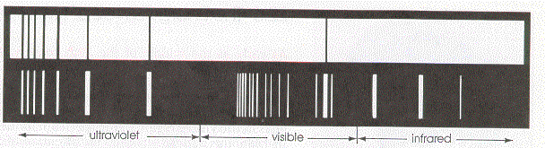

Absorption spectrum

Emission spectrum

(Sodium vapour)

# The Franck – Hertz experiment

Earlier studies of emission and absorption spectra had revealed that atoms emit and absorb light energy only at discrete, characteristic wavelengths or energies, but there was no theory that could explain how they worked. A significant contribution to our understanding of atomic structure was provided by a team of two German physicists, James Franck and Gustav Hertz, in 1914. Franck and Hertz devised an experiment to investigate how atoms absorb en­ergy in collisions with fast-moving electrons.

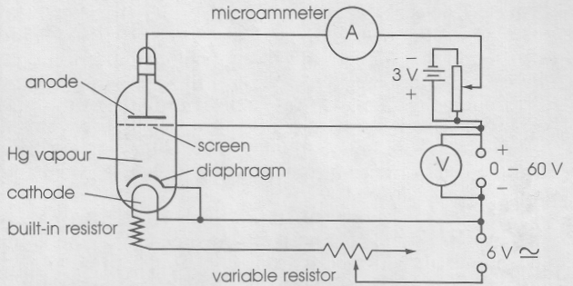Using an apparatus similar to that shown, free electrons emitted from the cathode were ac­celerated through low pressure mercury vapour by a voltage applied to the wire screen anode. (An electron accelerated by a potential difference of 5.0 V, for example, acquires a kinetic energy of 5.0 eV.) Most of the electrons went through the screen and were collected by the anode plate beyond the screen. This flow of electrons constituted an electric current, which was measured by a microammeter.

The experiment consisted of gradually increasing the accelerating voltage and, for each value, measuring the electric current passing through the mercury vapour and collected by the plate. Franck and Hertz found the following results:

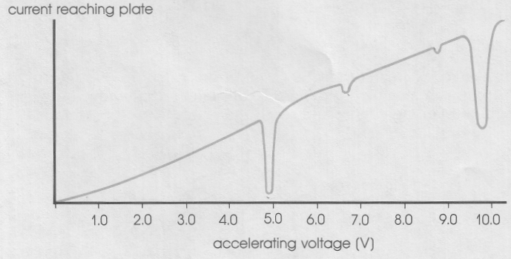• As the accelerating voltage was increased slowly from zero, the current gradually increased as well.

• Then, at a voltage of 4.89 V, the current dropped dramatically.

• As the voltage was increased further, the current once again began to increase.

• Similar minor decreases in current also occurred at voltages of 6.67 V and 8.84 V.

• Another significant decrease in current occurred at a voltage of 9.8 V.

The results indicated that for certain values of bombarding electron energy (4.89 eV, 6.67 eV, 8.84 eV, 9.8 eV, . . . ) the electrons do not "make it" through the mercury vapour. Their energy is lost because of collisions with mercury vapour atoms. The proposed explanation was simple, yet elegant:

•

mercury atom

4.0 eV

electron

•

4.0 eV

• Whenever the energy of the incident electrons was less than 4.9 eV, they simply bounced off any mercury atoms they encountered with no loss of energy and continued on as part of the current.

• Those electrons with an energy of 4.9 eV that collided with a mercury atom transferred all of their energy to the mercury atom and, therefore, with no energy remaining, did not reach the plate.

• At energies greater than 4.9 eV, electrons colliding with mercury atoms can give up 4.9 eV in the collision and still move off with the remaining energy and reach the plate.

•

mercury atom

6.0 eV

electron

•

1.1 eV

•

mercury atom

4.9 eV

electron

•

0 eV

• At electron energies of 6.7 eV and 8.8 eV, collisions once again rob the bombarding electrons of all their energy, but these col­lisions are less likely to occur than those at 4.9 eV, (i.e. mercury atoms prefer to absorb 4.9 eV of energy) so that the effect on the current is less severe.

• At 9.8 eV, electrons are able to make a collision, losing 4.9 eV of energy, and then go on to make a second similar collision with another mercury atom, losing an­other 4.9 eV of energy. Since these collisions are more probable, a sharper decrease in current occurs.

The significant result of the Franck-Hertz experiment is that atoms can change their internal energy as a result of collisions with electrons,but only by specific, discrete **quanta** or amounts of energy. Their interpretation was that the electrons within the atoms normally exist in a **ground state** (0 eV). When they are given enough energy, they **jump** up to an **excited energy state**. Only certain excitation levels are allowed – i.e. electrons can only absorb specific amounts of energy. The diagram on the right is a representation of the energy states of a mercury atom. Energy diagrams for other elements would look similar, but they would have different excitation energies. The **ionization level** is when one of mercury’s electrons is given enough energy that it leaves the atom resulting in a positive mercury ion.

10.4 eV

8.84 eV

6.67 eV

4.89 eV

0 eV

ground state

1st excitation level

2nd excitation level

3rd excitation level

ionization level

many other excitation levels exist in this region

As the experiment progressed Franck and Hertz also noted that the mercury vapour began to emit light. The next step in their experiment was to measure the wavelength of the light **emitted** by the **excited** mercury atoms. When the input electron had energy of 9.00 eV, the mercury vapour released photons that produced spectral lines at 686.8 nm, 572.9 nm, 312.3 nm, 254.2 nm, 186.4 nm and 140.6 nm. Using Planck’s equation, the energies of each of these wavelengths could be calculated. For example, for the 254.2 nm light

 = **4.89 eV**

A complete list of the corresponding energies of the photons yields:

 

Note that these wavelength/energy pairs correspond to the excitation levels of mercury vapour.

140.6 nm 8.84 eV

186.4 nm 6.67 eV

254.0 nm 4.89 eV

312.3 nm 3.98 eV

What about these wavelength/energy pairs?

572.9 nm 2.17 eV

686.8 nm 1.81 eV

Franck and Hertz interpreted the energies and wavelengths as the result of jumps of mercury atom electrons falling from excitation states down toward the ground state. As the electron **falls** or de-excites back toward the ground state, **it releases its energy in the form of a photon**. In general, the photon’s energy is determined by the difference in the initial (higher) and final (lower) energy levels.



The wavelength or frequency of the photon may be calculated using Planck’s equation.

254.0 nm photon (4.89 eV)

186.4 nm photon

(6.67 eV)

140.6 nm photon (8.84 eV)

10.4 eV

8.84 eV

6.67 eV

4.89 eV

0 eV

The diagram on the right illustrates the emission of photons when electrons fall back from an excitation state **directly to the ground state**.

The remaining wavelength/energy pairs above can be explained by **intermediate** jumps to lower energy states. For example, an electron in the third excitation state could fall to the second level before falling to the ground state. The energy of the photon for the jump from E3 to E2 would be the difference in their energies 8.84 eV – 6.67 eV = 2.17 eV. The 2.17 eV photon has a wavelength of

= 572.9 nm.

which corresponds to one of the observed wavelengths emitted by mercury. The diagram on the right illustrates the emission of photons when electrons fall back from a high excitation state to another **intermediate** excitation state.

686.8 nm photon (1.81 eV)

312.3 nm photon

(3.98 eV)

579.2 nm photon (2.17 eV)

10.4 eV

8.84 eV

6.67 eV

4.89 eV

0 eV

Thus the emission spectrum of an element is explained by a combination of de-excitations to the ground state and de-excitations to intermediate excitation states.

# Summary of spectra and excitation states

## Absorption of energy

Atoms can **absorb energy** in two ways:

1. **By collisions with high energy electrons**. In these collisions the electron in the atom absorbs only the amount of energy corresponding to a jump from the ground state to an excitation state. The incoming electron continues on with the remaining energy. For example, a 6.00 eV incoming electron colliding with a mercury atom will lose 4.89 eV to the atom and then continue on with an energy of 1.11 eV. Note, for this type of energy absorption, the incoming particle need only have an energy greater than the first excitation energy.

10.4 eV

8.84 eV

6.67 eV

4.89 eV

0 eV

•

6.00 eV

electron

•

1.11 eV

mercury atom electron jumps to first excitation level

2. **By absorbing a photon**. In this case, the atom will absorb **only** those photons that have energies that **exactly match** the excitation state energies. Since electrons normally reside in the ground state, this means that it will absorb only those photons that match its excitation states from the ground level. Therefore, when full spectrum white light is sent through a gas, only those wavelengths of light that correspond to the excitation states of the gas are absorbed by the gas. The remaining wavelengths simply pass through the gas. This explains the dark lines for absorption spectra.

177 nm photon (7.00 eV)

207 nm photon

(6.00 eV)

186 nm photon (6.67 eV)

10.4 eV

8.84 eV

6.67 eV

4.89 eV

0 eV

207 nm photon

(6.00 eV)

177 nm photon

(7.00 eV)

incoming photons

outgoing photons

## Release of energy

Once atoms have been excited they will eventually fall back to the ground state. Some atoms, for example hydrogen, will return to the ground state immediately after being excited. Other atoms, like phosphorous, can stay in an excited state for hours before returning to the ground state. This is why divers watches have phosphorous paint numbers – they will continue to emit light for hours.

Atoms can fall back to the ground state in one of two ways:

1. The atom can fall **straight** back to the ground state from the excitation state. In this case, one high energy photon is emitted.
2. The atom can fall through a **series of intermediate** excitation states to the ground state. In this case, several lower energy photons will be emitted.

254.2 nm photon (4.89 eV)

312.3 nm photon

(3.98 eV)

140.6 nm photon (8.84 eV)

10.4 eV

8.84 eV

6.67 eV

4.89 eV

0 eV

572.9 nm photon

(2.17 eV)

186.4 nm photon

(6.67 eV)

or

or

The emission of photons when atoms fall back toward the ground state explains two things about emission spectra:

1. Bright lines of emission spectra correspond with the dark lines of absorption spectra for the same element or molecule.
2. The presence of **more lines** in emission spectra compared to absorption spectra can be explained by the intermediate jumps that can occur when atoms fall toward their ground state.

# Practice problems

A Frank-Hertz experiment was carried out with on Lichtium vapour in a chamber. The energies of the electrons sent into the chamber (Einput) and those coming out of the chamber (Eouput) were measured and the data is given below. What can be inferred about the possible energy levels within this fictitious atom? Assume that the ground state energy is zero.

Einput (eV) Eoutput (eV)

4.0 4.0

5.0 0.0

5.5 0.5

6.0 1.0

6.5 1.5

7.0 0.0 or 2.0

7.5 0.5 or 2.5

8.0 0.0 or 1.0 or 3.0

8.5 0.5 or 1.5 or 3.5

1. Draw an energy level diagram for Lichtium.

2. What wavelengths of light would you expect Lichtium to absorb? (248 nm, 177 nm, 155 nm)

3. What wavelengths of light would you expect Lichtium to emit? (total of six wavelengths)

4. If an atom was excited to the fourth excitation state, how many possible wavelengths of light would be emitted when the atom fell to its ground state? (10)

# Hand- in assignment

1. When a solid, liquid or very dense gas is heated until it gives off light and the light is passed through a prism, a(n) _______________ spectrum is produced.

2. When a rarefied gas is excited with electrical energy until it gives off light which is passed through a prism, a(n) _______________ spectrum is produced.

3. Why can an emission spectrum be used to positively identify different elements or molecules in their gaseous states?

4. When white light is passed through a gas and then allowed to go through a prism, it will produce a(n) _______________ spectrum.

5. What is the significance of the results of the Frank-Hertz experiment?

6. What is meant by the following terms:

A. An atom's ground state?

B. An atom's excitation states?

C. An atom's ionization energy?

7. An electron of energy 4.7 eV collided with an atom called Chekleyium and was reflected with an energy of 1.4 eV. Immediately after the atom emitted a photon. What is the frequency of the photon? (8.0 x 1014 Hz)

8. A mercury atom has stationary energy states of 4.9 eV, 6.7 eV and 8.8 eV above the ground state.

A. An electron with an energy of 3.6 eV collides with an unexcited atom. Estimate the energy of the reflected electron.

B. Another electron with an energy of 6.8 eV is incident on the atom. What is (are) the possible energy(ies) of the reflected electron?

9. A Frank-Hertz experiment was carried out with a fictitious gas in a chamber. The energies of the electrons sent into the chamber (E1) and those coming out of the chamber (E2) were measured and the data is given below. What can be inferred about the possible energy levels within this fictitious atom? Assume that the ground state energy is zero.

Einput (eV) Eoutput (eV)

6.4 6.4

6.7 6.7

6.8 0.0

7.8 1.0

8.7 0.0 or 1.9

8.9 0.2 or 2.1

9.1 0.4 or 2.3

9.3 0.0 or 0.6 or 2.5

9.5 0.2 or 0.8 or 2.7

10. What happens to a mercury atom that has been raised to its first excitation level by a collision with an electron?

11. What is the explanation for the absorption spectrum of an element?

12. Why are most gases invisible to the human eye?

13. Why does an emission spectrum contain more lines than an absorption spectrum?

14. What will happen when an electron of energy 5.0 eV collides with a mercury atom? What will happen when a photon of energy 5.0 eV hits a mercury atom?

15. A spectroscope is used to examine the white light that has been passed through a sample of mercury vapour. Dark lines, characteristic of the absorption spectrum of mercury, are observed.

A. What eventually happens to the energy the mercury vapour absorbs from the white light?

B. Why, then, are the absorption lines dark?

16. The emission spectrum of an unknown substance contains lines with the following wavelengths: 172 nm, 194 nm, and 258 nm. If these all represent transitions to the ground state (a) calculate the energies of the first three excitation states, and (b) determine the wavelengths of three other lines in the substance’s emission spectrum. (4.82 eV, 6.41 eV, 7.23 eV; 516 nm, 782 nm, 1517 nm)

17. What is the energy difference between the two energy levels in a sodium atom that give rise to the emission of a 589 nm photon? (2.1 eV)

18. An electron whose kinetic energy is 3.0 eV collides with a free mercury atom. What will be the kinetic energy of the electron after the collision? (3.0 eV)

19. Electrons are accelerated in a Franck-Hertz experiment through mercury vapour with a potential difference of 7.0 V. What are the energies of all the photons that may be emitted by the mercury vapour? (4.9 eV, 6.7 eV, 1.8 eV)

20. If an atom emits a photon of wavelength 684 nm, how much energy dos the atom lose? (1.82 eV)